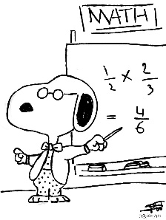

**Honors Pre-Calculus**

**Ambrosino Room 301**

**Spring 2020 Syllabus cell: 336-706-1908**

Welcome to **Honors Pre-Calculus**! Pre-Calculus provides students an honors-level study of trigonometry, advanced functions, analytic geometry, and data analysis in preparation for calculus. All students are expected to participate in class and complete all assignments. If you choose not to meet that expectation, you will not do well in this class. The units that we will cover this semester are listed below:

1: Functions and Their Graphs 7: Analytical Trigonometry

2: Polynomial Functions 8: Additional Topics in Trigonometry

3: Rational and Radical Functions 9: Polar and Parametric Equations

4: Exponential and Logarithmic Functions 10: Sequences and Series

5: Conic Sections 11: Limits

6: Trigonometric Functions



**Classroom Rules and Expectations**

* Arrive to class on time.
* Turn in all assignments on time.
* Do not talk while I am talking!! It is rude, disrespectful, and a distraction to everyone in the class.
* **NO** cell phones should be used during class time.
* **NO** meals in class.
* Expect **every** day to be an important day. NO FREE DAYS!

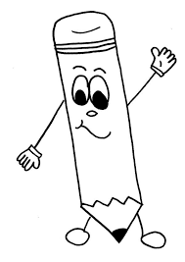**Supplies**

**Required: Wish List:**

3-ring binder Copy Paper

Notebook paper Color Copy Paper

Pencil Tissues

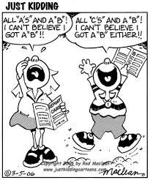 Colored pencils or pens Hand Sanitizer

**Grading**

Tests 50%

Assignments (classwork, homework, participation) 25%

Quizzes 25%

**Classwork Policy**

* May be graded for completion or accuracy.
* Students will have one participation classwork grade per nine weeks. Points will be deducted from this grade for cell phone use, talking during notes, not working in class, sleeping in class, talking while others are testing, etc.

**Exam**

There is a state exam for this class.

**Tests and Quizzes**

Students should expect at least one quiz or test each week. Students who miss a test or quiz must schedule and make it up within 5 school days.

**In Summary**

IF you want to do well - stay off your phone and do your work during class. DO NOT save it for homework. (No one should be on an electronic device watching movies, playing games, or doing other assignments during class.)

These are my expectations. If you choose not to comply with them, then DO NOT ask for help when you DO NOT understand something that I just taught. DO NOT ask me to explain why your grade is not an A.

If I see that any of my expectations are not being met, then I will contact parents. :/

**Absences & Tardies**

**You are expected to be in class every day.** However, each student is allowed three absences. Each day more than that will result in 45 minutes of earned make-up time with me.

**You are expected to be in class on time.** If you arrive after the start time of class, then YOU ARE LATE. After the third tardy, you will have to serve lunch detention the next day.

**Cheating**

Cheating will result in a grade of zero for the assignment, test, or quiz.

**Make-up Work**

Students are responsible for getting any notes that were missed. Any handouts that were given will be located in the missing work folder.

### Extra Credit Policy

Extra Credit will NOT be given to allow a student to pull up his/her grade. Students should prepare on a daily basis, take advantage of tutoring opportunities, and always do their best.

**Taking Notes**

Students are expected to take DETAILED notes during class. Students may NOT take a picture of the notes.

Notes should be used as a helpful resource and should be ORGANIZED and kept through the end of the semester.

* Notes will be checked daily & will count as a classwork grade.

**Homework Policy**

Homework is assigned every day and will be checked periodically for completion or for accuracy. It is due at the very beginning of class and any work received after the last call for it will earn half credit.

* Full credit is earned if all problems have been attempted.
* Half credit is earned if the assignment is incomplete.
* Zero credit is earned if very few problems have been attempted.
* Homework may be turned in ONE day late for a grade of 50.